BSCS FINAL PROJECT

Defense Drill



Mam Rubab Javaid

Presented by:
Group ID:F22SE046

Student Reg# Student Name
L1f19bsse0128 Abdul Moiz Adnan
L1f19bsse0132 Hassan Islam
L1f19bsse0303 Rimsha Gafoor

Faculty of Information Technology

University of Central Punjab
Defense Drill

By
Hassan Islam L1F19BSSE0132
Abdul moiz Adnan L1F19BSSE0128
Rimsha Gafoor L1F19BSSE0303

Project submitted to

Faculty of Information Technology,

University of Central Punjab,

Lahore, Pakistan.

in partial fulfillment of the requirements for the degree of

Bachelor of Science in Software Engineering

Project Advisor |  | Manager Projects

Abstract
Now a days due to rampant crimes in the country which have no end in sight, ordinary citizens are being caught up in situations they are not ready for. They are unable to protect themselves and those close to them because they do not have the required skillset to remain calm and act in accordance to avoid getting hurt, robbed, or killed. To counteract that we have developed an app which has courses for beginners as well as advanced users which will provide the user with the skillset to at-least defend themselves in dangerous situations.
At the end, the results that would be acquired are: provided the user with ability to defend themselves and make a citizen not so helpless in dangerous situations anyone. Intermediate users and advanced users could be eligible for a career in mixed martial arts by participating in a tournament to test their ability according to their badge levels.

Motivation:
The motivation behind developing the Martial Arts Training Mobile Application stemmed from a deep passion for martial arts and a desire to provide enthusiasts with a comprehensive and accessible training solution. This project was driven by the following key motivations:
- Accessibility: Martial arts training should be accessible to individuals of all skill levels, regardless of their geographical location or access to training facilities. The mobile application allows users to engage in training sessions and learn techniques from the comfort of their own homes, making martial arts training more accessible to a wider audience.
- Personalized Training: Every martial artist has unique goals and needs. The application was designed to cater to individual preferences and provide a personalized training experience. By offering different training levels and sessions, users can tailor their training journey to their specific skill level, interests, and objectives.
- Visual Guidance: Visual guidance is crucial in understanding and mastering martial arts techniques. The inclusion of animated training GIFs in the application provides users with a visual demonstration of each technique, enhancing their understanding and facilitating proper execution.
- Progress Tracking and Motivation: Progress tracking plays a vital role in maintaining motivation and gauging improvement. The application's progress tracking features allow users to monitor their training history, session completion rates, and performance statistics. By visualizing their progress, users are motivated to stay consistent and achieve their martial arts goals.
- Repetition Counting Innovation: Repetition counting is an essential aspect of martial arts training, as it helps users track their performance and measure progress. By utilizing the device's camera to automatically count repetitions, the application introduces an innovative and convenient method of tracking exercise repetitions, freeing users from the need to manually count.
- Support and Community: Engaging in martial arts training is not just about the physical aspect but also about being part of a supportive community. The application aims to foster a sense of community by providing access to user support forums, where users can connect with fellow enthusiasts, share experiences, and seek guidance from experts.

Problem statement:
The problem we aim to address is the limited accessibility and personalized training options in traditional martial arts training. Many individuals, regardless of skill level, may face challenges attending physical martial arts classes regularly due to geographical limitations, time constraints, or lack of access to training facilities. Furthermore, traditional classes often provide a one-size-fits-all approach, making it difficult for individuals to receive personalized training tailored to their specific skill level and goals. Our work focuses on developing the Martial Arts Training Mobile Application, which seeks to bridge these gaps and offer a comprehensive, accessible, and personalized training solution for martial arts enthusiasts, empowering them to pursue their training goals efficiently and effectively.

Approach:
- Problem Identification: The development team would start by identifying the problem they want to address, which is providing accessible and effective martial arts training for enthusiasts.
- Market Research: Conducting market research to understand the needs and preferences of the target audience. This includes studying existing martial arts training apps, user feedback, and trends in the martial arts community.
- Feature Design and Prototyping: Based on the research, the team would design the application's features, including three levels of training, animated training GIFs, and the camera-based repetition counting. Prototypes may be created to test and refine the user interface and functionalities.
- Data Collection and Analysis: For the camera-based repetition counting feature, the team might use simulation or data analysis to train and fine-tune the algorithm that detects and counts repetitions accurately.
- Platform and Language Selection: The team would decide on the mobile platforms (Android, iOS) to target and the programming languages and frameworks to use (react js, python etc).
- Development and Testing: The application would be developed, and iterative testing would be conducted to ensure functionality, usability, and bug fixing. Multiple devices and scenarios might be tested to ensure broad compatibility.

Results:
The Defense Drill mobile application has successfully provided martial arts enthusiasts with an accessible and engaging platform for training. With its user-friendly interface, comprehensive training modules, instructional animated Gifs, and step-by-step guides, users can enhance their skills in various martial arts styles. The app's features,,badge system personalized profiles, reps counter elements have contributed to a motivating and supportive learning environment. Furthermore, the offline access capability and emphasis on safety precautions have ensured convenience and user safety. Overall, Defense Drill has had a positive impact on the martial arts community by offering a comprehensive and convenient training resource.

Conclusions:
In conclusion, the development of a React Native app for teaching martial arts offers numerous benefits in terms of accessibility, user engagement, and exercise tracking. By utilizing the power of mobile technology and incorporating features such as exercise categorization, progress tracking, and rank awards, the app provides an interactive and comprehensive platform for martial arts enthusiasts.
The use of React Native as the framework for app development ensures cross-platform compatibility, enabling users to access the app on both iOS and Android devices. The integration of Firebase for user authentication facilitates a seamless sign-in and sign-up process, enhancing the overall user experience.
With the inclusion of a custom GIF library showcasing martial arts exercises, learners can visually understand and practice the techniques effectively. Additionally, the incorporation of a repetition counter, controlled remotely through a desktop application, enables users to track their exercise repetitions accurately and monitor their progress over time
Dedication
The creation of the Martial Arts Training Mobile Application is a result of unwavering dedication and passion for martial arts and technology. Our team of developers, designers, and martial arts enthusiasts came together with a shared commitment to making martial arts training accessible, engaging, and personalized for all. Countless hours of research, development, and testing were devoted to crafting a user-friendly application that seamlessly integrates animated training GIFs and innovative camera-based repetition counting. We are dedicated to empowering users in their martial arts journey, from beginners seeking to learn fundamental techniques to experienced practitioners aiming to refine their skills. Our dedication extends to providing ongoing support, listening to user feedback, and continuously improving the application to meet the evolving needs of the martial arts community. This dedication underpins our vision to inspire, motivate, and elevate the martial arts experience for every user, fostering a community united by their shared passion for the art and discipline of martial arts.

Acknowledgements
I would like to express my heartfelt gratitude to my advisor Mam Rubab Javaid for her invaluable guidance mentorship and support throughout the development of the Martial Arts Training Mobile Application. Her expertise, encouragement, and dedication have been instrumental in shaping the direction of this project and ensuring its successful completion. I am sincerely grateful for her patience and continuous feedback, which has significantly enriched the quality and impact of the application. Additionally, I extend my appreciation to the entire team of developers and contributors who worked diligently to bring this project to fruition. Their collective effort and collaboration have been a driving force behind the realization of our vision. Furthermore, I extend my thanks to the martial arts community for their enthusiasm and engagement, as their valuable insights have inspired us to continuously improve the application to better serve their needs. Lastly, I express my gratitude to all users of the Martial Arts Training Mobile Application for their trust and support, as it is their passion for martial arts that fuels our commitment to delivering a transformative training experience.
List of Figures

Provide a list of all figures along with their captions
List of Tables

Provide a list of all tables along with their

Table of Contents
Abstract i
Dedication iv
Acknowledgements iv
List of Figures v
List of Tables vi
Table of Contents viii
Revision History x
Chapter 1. Introduction 1
1.1 Product (Problem Statement) 1
1.2 Background 1
1.3 Objective(s)/Aim(s)/Target(s) 1
1.4 Scope 1
1.5 Business Goals 2
1.6 Challenges 2
1.7 Learning Outcomes 2
1.8 Nature of End Product 2
1.9 Related Work/ Literature Survey/ Literature Review 3
1.10 Document Conventions 4
Chapter 2. Overall Description 5
2.1 Product Features 5
2.2 Functional Description 5
2.3 User Classes and Characteristics 6
2.4 Design and Implementation Constraints 7
2.5 Assumptions and Dependencies 7
Chapter 3. System Requirements 8
3.1 Functional Requirements 8
3.1.1 Requirements Analysis and Modeling 13
3.2 Nonfunctional Requirements 17
3.2.1 Performance Requirements 17
3.2.2 Safety Requirements 17
3.2.3 Security Requirements 17
3.2.4 Additional Software Quality Attributes 17
Chapter 4. Technical Architecture 18
4.1 Application and Data Architecture 18
4.2 Component Interactions and Collaborations 22
4.3 Architecture Evaluation 24
Chapter 5. Detailed Design and Implementation 25
5.1 Component-Component Interface 25
5.2 Component-Human Interface 25
5.3 Screenshots/Prototype 26
5.3.1 Workflow 26
5.3.2 Screens 27
Chapter 6. Test Specification and Results 31
6.1 Test Case Specification 31
Chapter 7. Project Completion Status/Conclusion 34
References 34
Appendix B IV & V Report 35
(Independent verification & validation) 35
Appendix C Deployment/Installation Guide 35
Appendix D User Manual 36

Revision History
Name | Date | Reason For Changes | Version

Introduction

Product (Problem Statement)
The problem we aim to address is the limited accessibility and personalized training options in traditional martial arts training. Many individuals, regardless of skill level, may face challenges attending physical martial arts classes regularly due to geographical limitations, time constraints, or lack of access to training facilities. Furthermore, traditional classes often provide a one-size-fits-all approach, making it difficult for individuals to receive personalized training tailored to their specific skill level and goals. Our work focuses on developing the Martial Arts Training Mobile Application, which seeks to bridge these gaps and offer a comprehensive, accessible, and personalized training solution for martial arts enthusiasts, empowering them to pursue their training goals efficiently and effectively.

Background
This Project aims to provide ordinary citizens with the knowledge and skill of self-defense. The tutors will also be able to sign up and upload their portfolios. The users will interact with the tutors through online seminar. This project provides the user beginner and if the user wishes to learn more, advanced skills which would enable the user to protect themselves and their loved ones in a dangerous situation. Complete new animations made by us to provide a visual representation of the martial arts move. The project also provides notifications of tournaments to pit users against each other according to badge/skill level. Freelance martial arts tutors can also hugely benefit from providing one-on-one lessons to confirming skill level for a fee. The app has image processing to ensure correct repetition of moves. This project has an app based designed to run efficiently on all systems with accurate responsiveness.

Objective(s)/Aim(s)/Target(s)
- We will make an app that provides a three-course program that teaches martial arts from beginner to the advanced level.
- An image processing module to calculate repetitions.
- A badge system that will award badges based on course completion. Complete new animations made by us to provide a visual representation of the martial arts move. Complete documentation and code of project

Scope
We will make an mobile app that provides a three-course program that teaches martial arts from beginner to the advanced level. The app would contain an image processing module to calculate repetitions. A badge system that will award badges based on course completion. The ability to create an account for user.

Business Goals
Our main business goals are:
- To provide martial arts training who cannot afford training institutes and outdoor tuitions.
- To provide earning platform for trainers.
- To provide free courses and paid online classes for trainee.

Challenges
The development of the Martial Arts Training Mobile Application was not without its challenges. Some of the key challenges faced during the project included:
Designing an intuitive user interface that accommodates users of different age groups and skill levels.
Ensuring the accuracy and reliability of the camera-based repetition counting feature across various devices and movements.
Integrating a diverse range of martial arts techniques and training sessions to cater to the preferences and interests of a wide audience.
Balancing the need for comprehensive content with the application's file size and performance.

Learning Outcomes
The development of the Martial Arts Training Mobile Application was not without its challenges. Some of the key challenges faced during the project included:
Designing an intuitive user interface that accommodates users of different age groups and skill levels.
Ensuring the accuracy and reliability of the camera-based repetition counting feature across various devices and movements.
Integrating a diverse range of martial arts techniques and training sessions to cater to the preferences and interests of a wide audience.
Balancing the need for comprehensive content with the application's file size and performance.

Nature of End Product
Our product will be mobile. The first module would be the sign in/sign up screen. The sign-up screen would lead to another module where data input would be communicated with database which would help the sign in module. Another module would be course selector including beginner, intermediary and advanced. This course selector would further expand to show step-by-step workouts with their respective self-made animations and videos. One module will be tutors sign in/ sign up. This module will work like user module. One module will consist of tutor hiring where their hourly rate and qualifications will be described including reviews. One module will consist of online seminar to give a platform between user and tutor. One module will handle the camera to ensure the repetition/count of martial arts moves performed through Image processing/AI. One module will handle the badge system that enables users to progress from beginner to intermediary and further to advanced. Without a badge the bigger courses will be locked out. The last module will consist of two categories including self-defense and professional martial arts. Respective user can only take professional martial arts after clearing the self-defense course. This professional category will have the same course structure and badge system as self-defense module.

Related Work/ Literature Survey/ Literature Review
Our application is different based on every level. We use animations to describe martial arts moves and provide a module that through image processing/AI to count repetitions of moves. We have various levels of courses for different end users based on their skill levels. Our app is all encompassing and does not focus only on one module provides the environment of a fully functioning useful application. As told to us by the project office, a project that relates to us is some gym app. Our app teaches martial arts not gym exercises and it does not correct posture counts the repetition of martial arts moves. The applications that are like ours include:
Martial Arts - Training and workouts which is an app like our project in a sense of organizing courses on different type of martial arts e.g., krav-maga, wing-chun.
Fighting Trainer is another martial arts app that focuses on animation to teach. However, our app only focuses on Mixed martial arts with these unique features and the number
of functionalities it offers which includes: Webinar for face-to-face interaction, Image-Processing to keep count of the repetitions performed through camera, Self-Made Animations with every move, Badge System to indicate whether user is eligible to use another course. The badges are provided when a tutor has a session with user, sees his skill according to the course attempted and giving the badge on successful attempt. Notifications of tournaments held and registration in accordance to badge level.

Document Conventions
This document uses the following conventions:

DDRL | Defense Drill
Main headings | Size 14 bold times new roman
Sub headings | Size 12 bold times new roman
Headings content | Font size 12 times new roman

Overall Description

Product Features
The major features of our application is:
- Enrollment or register
- Self-made animations
- levels of training beginner intermediate and advanced
- Push Notifications and Reminders
- badge levels
- repetitions counter

Functional Description
DFD level 0:

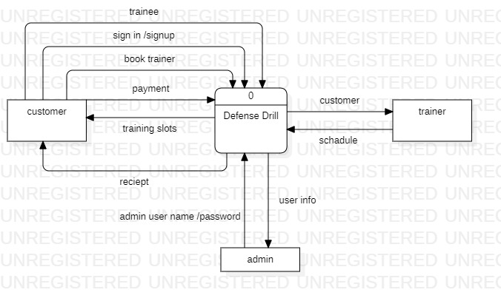

DFD level 1:

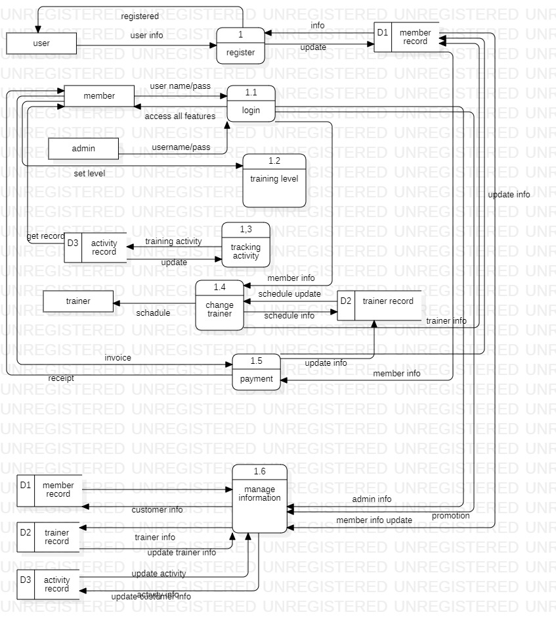

User Classes and Characteristics
We have 2 levels of users

- User module: This is a normal level of user who will be very few number of functionality for website and mobile application.
- Administration module: This user is an admin type who has full rights on the system

Design and Implementation Constraints
- The information of all users like schedule, activity and self-made animations must be stored in database that is accessible by the website and mobile application.
- SQ lite will be used as database.
- User may access its web from any computer that has internet browsing capabilities and an internet connections and on smart phones mobile app must be installed.
- Smart phone memory should be above 2 gb for smooth running of Defense drill Application.
- Camera specs must be above 8 megapixel for repetition counting without any error.
- Users must have their correct usernames and passwords to enter into their online profile and do actions.
- Language requirements: software must be multilingual, including the following Languages: English, urdu and Hindi.
- This app must be able to access the devices GPS to offer location based couching facilities

Assumptions and Dependencies
- If no internet connection is available, users will be unable to log in or access any functionality of the app.
- This project needs the following third party product
- SQ lite database for storing data
- Unregistered users will have no access to the app.
- Users will only be permitted to register and gain access to the app once they agree to the terms of service agreement.

System Requirements

Functional Requirements
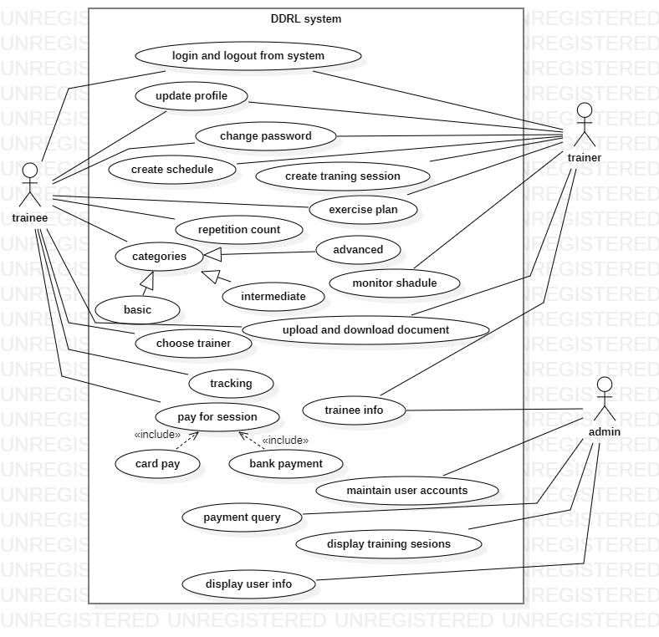

Enrolment and registered
Identifier |  | UC-1
Purpose |  | Get registered and enrolled to access courses and activities
Priority |  | High
Pre-conditions |  | User has been enrolled in the app
Post-conditions |  | user get access to the app
Typical Course of Action
S# | Actor Action |  | System Response
1 | User will enter email |  | System have verified the email and request to set password
2 | User will enter password in password field |  | System check password format and shows valid password.
3 | User will select fb login or gmail login instead of set email and password |  | System will get permission from user.
4 | User will press sign up button to complete enrollment |  | System will login
Alternate Course of Action
S# | Actor Action |  | System Response
1a | User will enter email |  | System will show invalid email or shows its already exist.
2a | User will enter wrong password format in password field |  | System will check password format and shows invalid password or show weak password.
Table 1: UC-1

Training routine
Identifier |  | UC-2
Purpose |  | Get routine of training activity according to user
Priority |  | Low
Pre-conditions |  | User get routine of training
Post-conditions |  | set daily routine
Typical Course of Action
S# | Actor Action |  | System Response
1 | User will select training tab |  | System will shows different training routines
2 | User will choose routine and set timing |  | System will save the selected routine and shows routine daily
3 | User will on the notification of routine which is selected by them |  | System will shows notification and remind user by sending notification
Alternate Course of Action
S# | Actor Action |  | System Response
3a | User will on the notification of routine which is selected by them |  | System will not shows notifications
Table 2: UC-2
Self-made animations:
Identifier |  | UC-3
Purpose |  | Check the steps with help of animations
Priority |  | Medium
Pre-conditions |  | User gets to know proper steps with the help of video etc.
Post-conditions |  | User gets self-made animation of martial arts steps
Typical Course of Action
S# | Actor Action |  | System Response
1 | User will login |  | System will check user name and password and get access to courses and trainings
2 | User will search activity name of step |  | System will show activity that is searched by user.
3 | User select the animation of particular activity |  | System will show the proper steps with proper detailing by animations
Table 3: UC-3

levels of traning
Identifier |  | UC-4
Purpose |  | Choose training level basic intermediate or advanced
Priority |  | Medium
Pre-conditions |  | User select training level basic intermediate or advanced
Post-conditions |  | User get training courses according to level
Typical Course of Action
S# | Actor Action |  | System Response
1 | User will login |  | System will check user name and password and get access to courses and trainings
2 | User will select training level |  | System will get training courses according to user request
Table 4: UC-4
Progress tracker
Identifier |  | UC-5
Purpose |  | Get to know the traning progress
Priority |  | Low
Pre-conditions |  | User select progress mode of day,week or month
Post-conditions |  | System shows progress info
Typical Course of Action
S# | Actor Action |  | System Response
1 | User will click on profile tab |  | System will show tab menu
2 | User will select tracker tab |  | System will show all record or progress which is done by trainee
3 | User select mode like day month week |  | System will shows information regarding mode of progress
Table 5: UC-5
Book and Schedule Classes
Identifier |  | UC-1
Purpose |  | Booking couch or trainer to get online classes
Priority |  | Medium
Pre-conditions |  | User will book tranier and get online classes
Post-  conditions |  | Book trainer and schadule classes
Typical Course of Action
S# | Actor Action |  | System Response
1 | User will select online classes |  | System will shows traners and with charges
2 | User will filter trainer and charges |  | System will shows filtered data of trainner
3 | User will select trainer and schedule |  | System will show schadule and trainer details
Alternate Course of Action
S# | Actor Action |  | System Response
2a | User will filter trainer and charges |  | System will not show any data
Table 1: UC-1
Repetition counter
Identifier |  | UC-1
Purpose |  | Get to know the repitition done by trainee
Priority |  | High
Pre-conditions |  | User will on the mode of repition counter
Post-conditions |  | System counts repitition
Typical Course of Action
S# | Actor Action |  | System Response
1 | User will start traning |  | System will start it according to user traning choice
2 | User will select reps counting mode. |  | System will get permission by user to allow camera
3 | User will allow camera |  | System will open camera and detect reps.
Alternate Course of Action
S# | Actor Action |  | System Response
3a | User will unallow camera |  | System will not open reps counter mode.
Table 1: UC-1

Requirements Analysis and Modeling
ER Diagram:

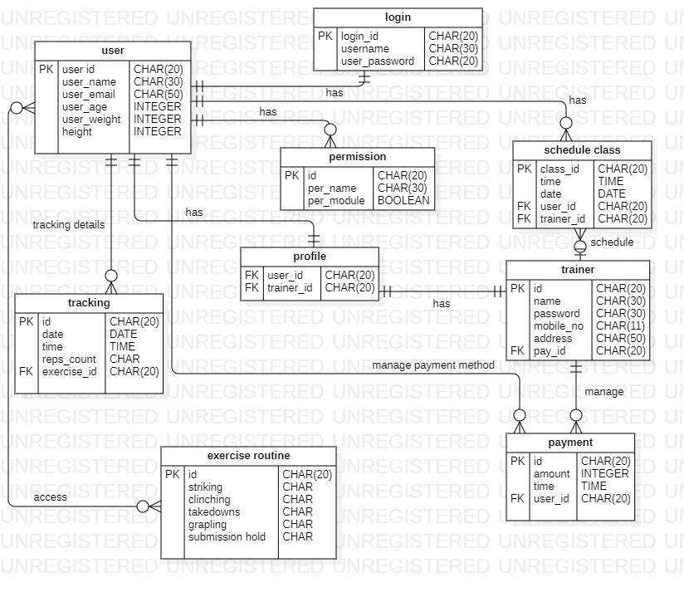

Use Case Diagram:

Abstract Class Diagram
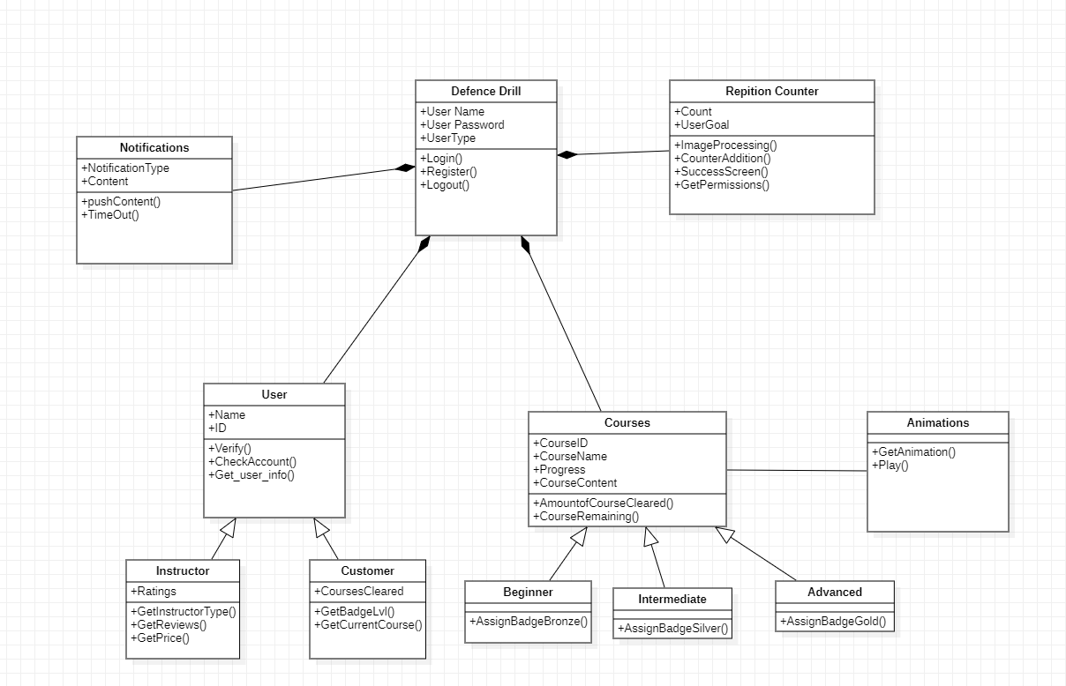

Sequence Diagram:

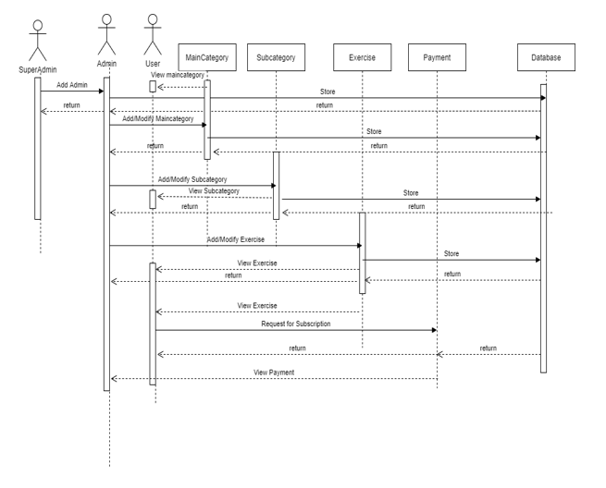

Nonfunctional Requirements

Performance Requirements
- System should be able to handle multiple users at a time using any of the web browsers.

Safety Requirements
- The system should not operate for 1 hour if user enter 6 times wrong PIN
- The system should not operate when vpn in ON.
- The system should not operate when app requirements will not meet up with device.

Security Requirements
- the user must log in with their user id which is provided by the system and by PIN which is set by user.
- System must verify the user by email during first time registration.
- User can reset its PIN by registered email.

Additional Software Quality Attributes
Availability:
system will be available when user needs.
Adaptability:
system will be run on any browser on desktop.
Flexibility:
Our system is flexible user can easily understand completely user friendly interface
Reliability:
Usability:
Easy for new or infrequent users to learn to use the system.

Technical Architecture

Application and Data Architecture
Architecture Diagram
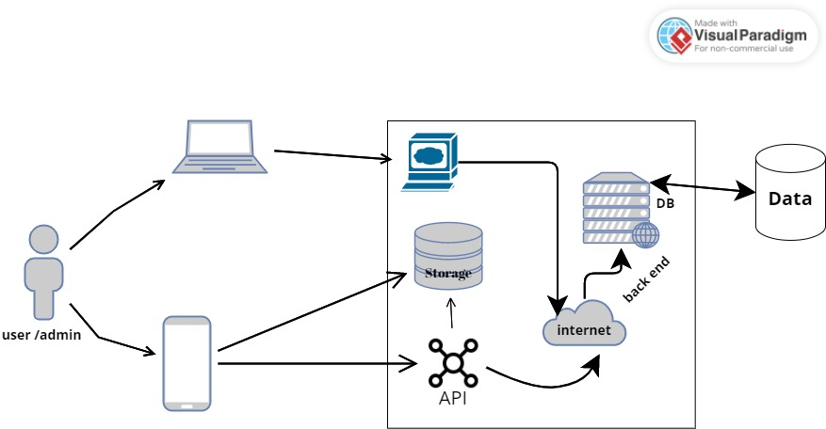

ERD diagram:

Class Diagram:

Activity Diagram:
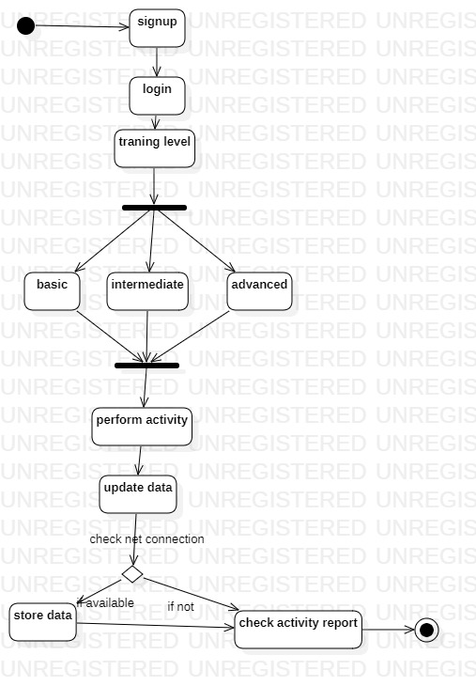

Component Interactions and Collaborations
Component Diagram:
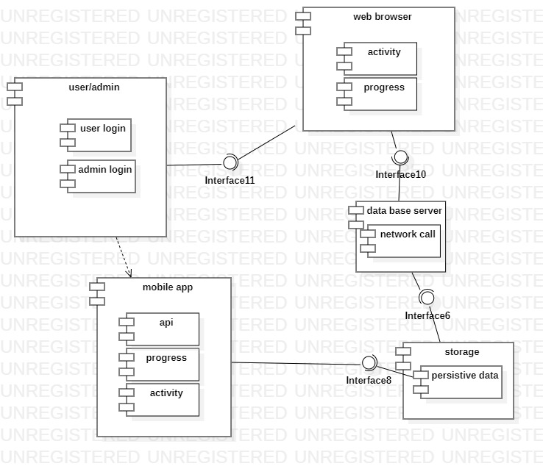

DFD

Architecture Evaluation
We use Computer vision technology in our project and the reason of using this technology is to analyze the images or video footage captured by the camera and track the movements and repitition of the user's body during martial arts training.

Pros:
- Accurate feedback: Computer vision technology can provide accurate feedback on the user's form and technique during martial arts training, which can be valuable for improving their skills.
- Real-time feedback: Computer vision technology can provide real-time feedback on the user's movements, allowing them to make adjustments and corrections as they train.
- Interactive experiences: Computer vision technology can enable the creation of interactive experiences within the application, such as virtual sparring or training exercises, that can enhance the user's training experience.
- Scalability: Computer vision technology can be scaled to accommodate a large number of users, making it suitable for use in a mobile application that is designed to reach a wide audience.
Cons:
- Complexity: Implementing computer vision technology in a mobile application can be complex and require specialized knowledge and expertise, which can increase development time and cost.
- Hardware limitations: Computer vision technology may require specific hardware requirements, such as high-quality cameras, that may not be available on all mobile devices.
- Environmental factors: Environmental factors, such as lighting conditions and background clutter, can affect the accuracy and reliability of computer vision technology in detecting motion.
- Privacy concerns: The use of computer vision technology in a mobile application may raise privacy concerns, as users may be uncomfortable with the collection and storage of their data.

Detailed Design and Implementation

Component-Component Interface
Sequence Diagram:
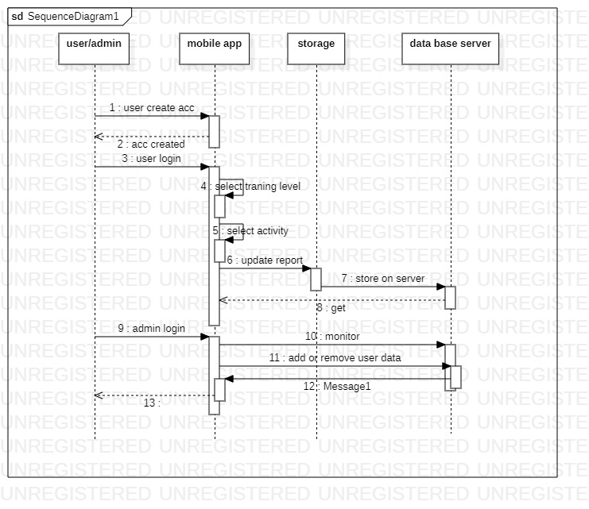

Component-Human Interface
- Login/Register screen - where users can log in to their existing account or create a new account
- Home screen - where users can see different sections of the app, such as training programs, virtual sparring, and progress tracking
- Training program screen - where users can select a specific martial arts training program
- User Profile screen - where users can view and update their personal information, such as their name, age, and martial arts experience
- Instructor profile screen-where trainer can see and update their informations and set their charges of classes etc
- Settings screen - where users can customize their app preferences, such as notifications and language options

Screenshots/Prototype

Workflow
Swimlane Diagram:
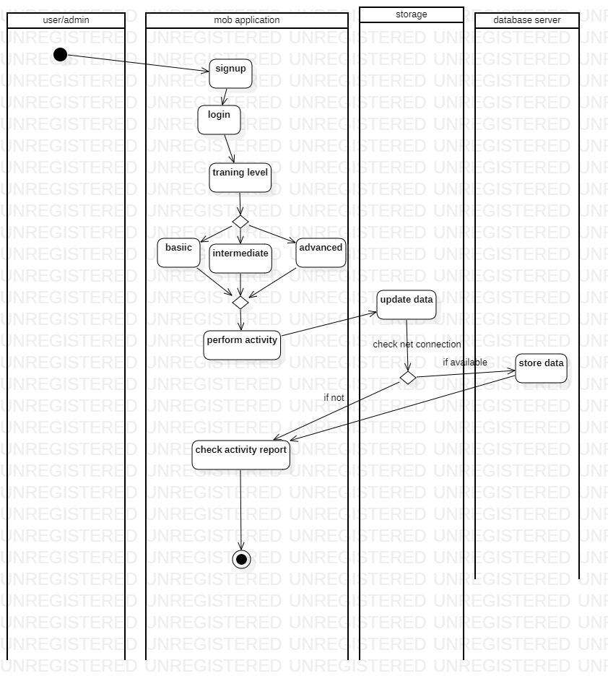

Screens
Sign in/Sign up
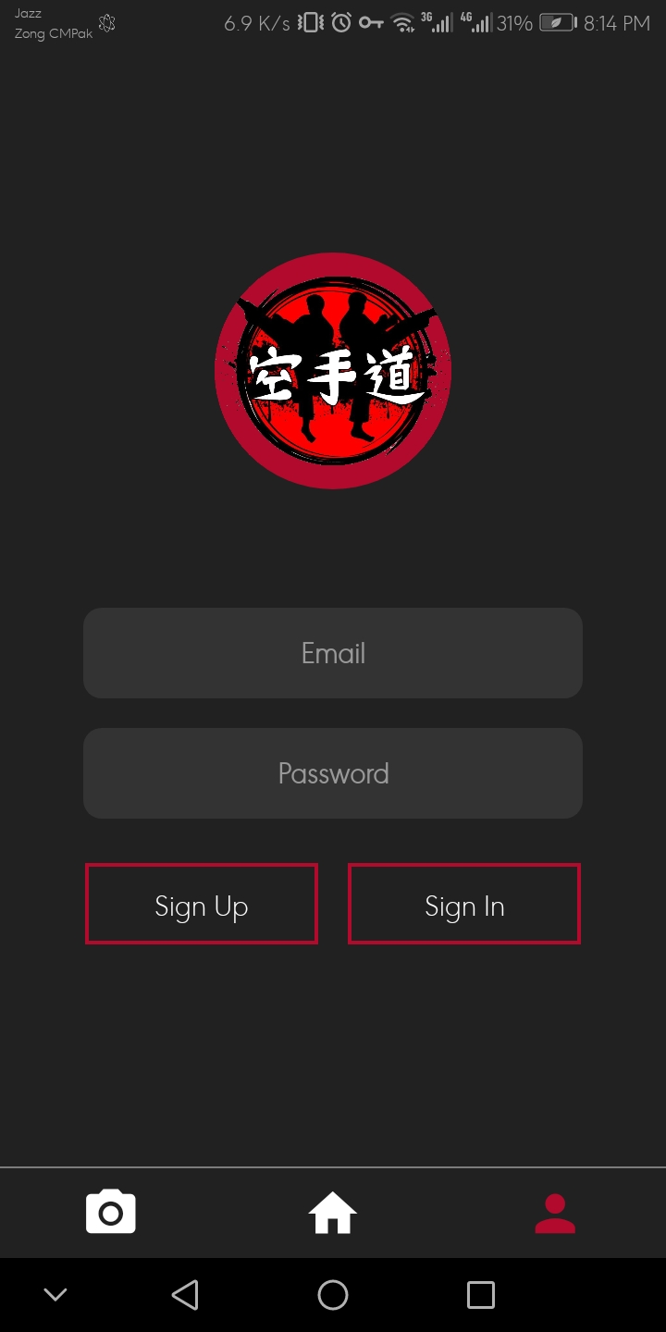
Levels:
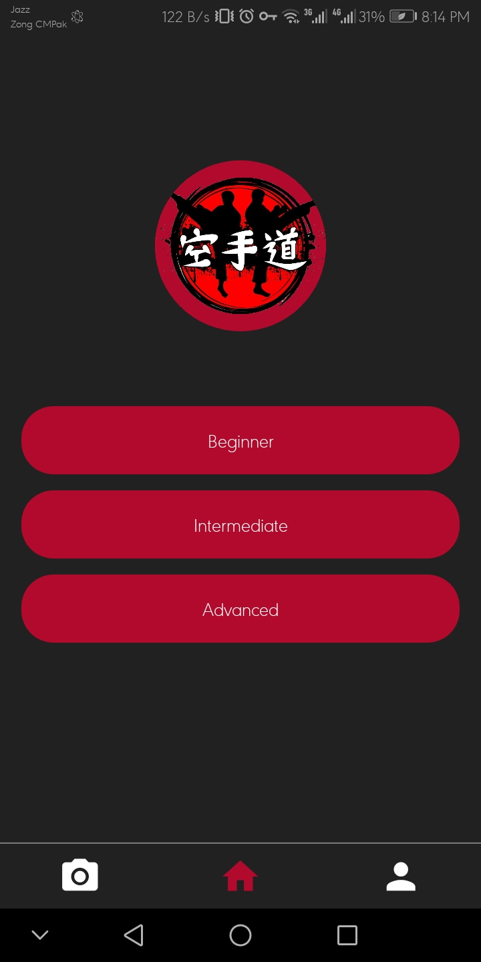

Basic levels:

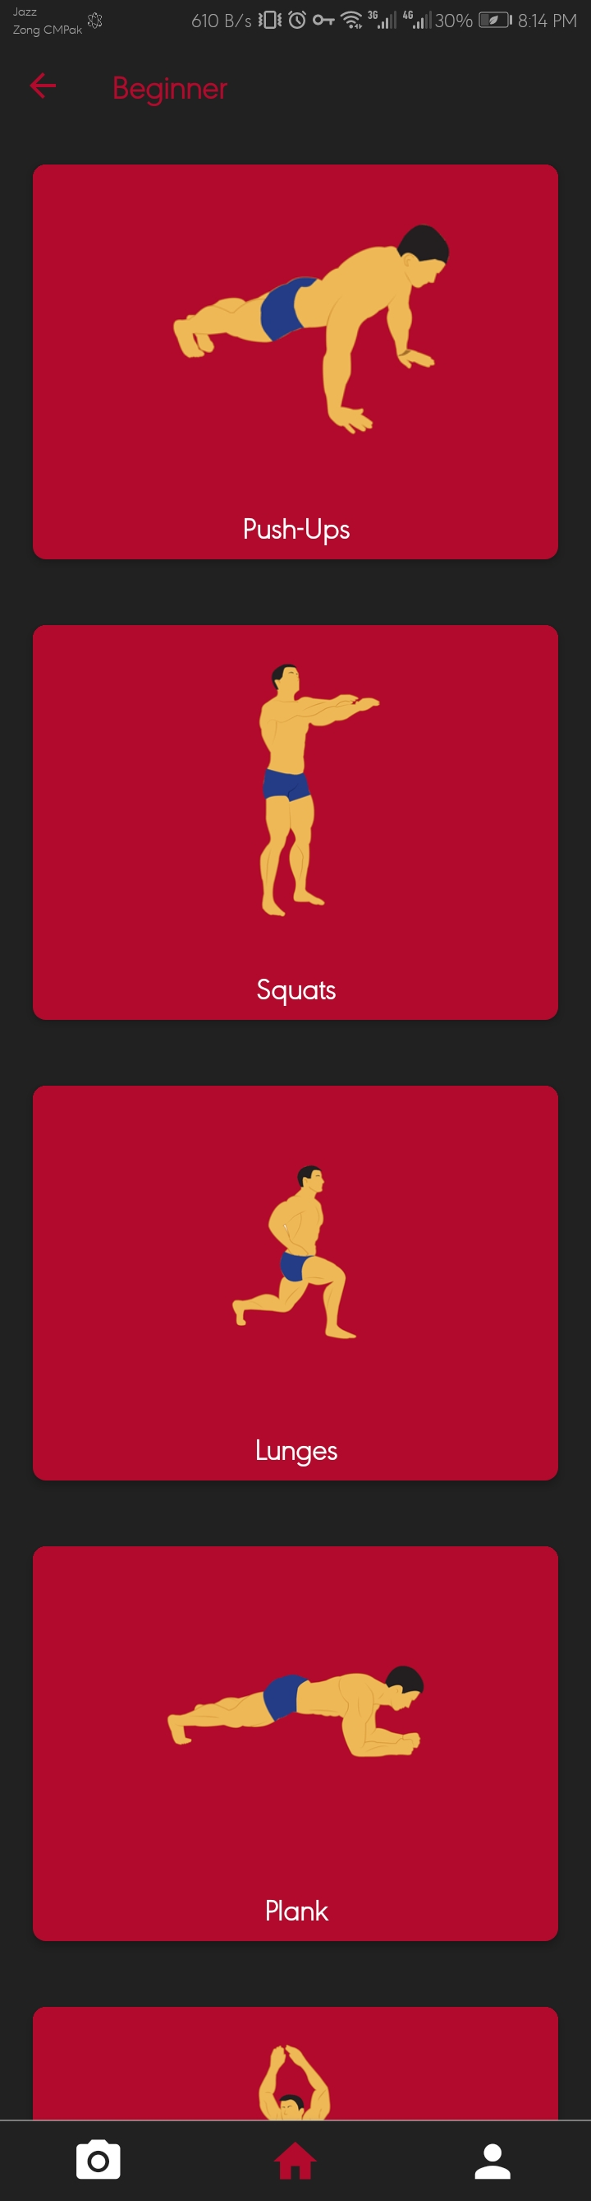
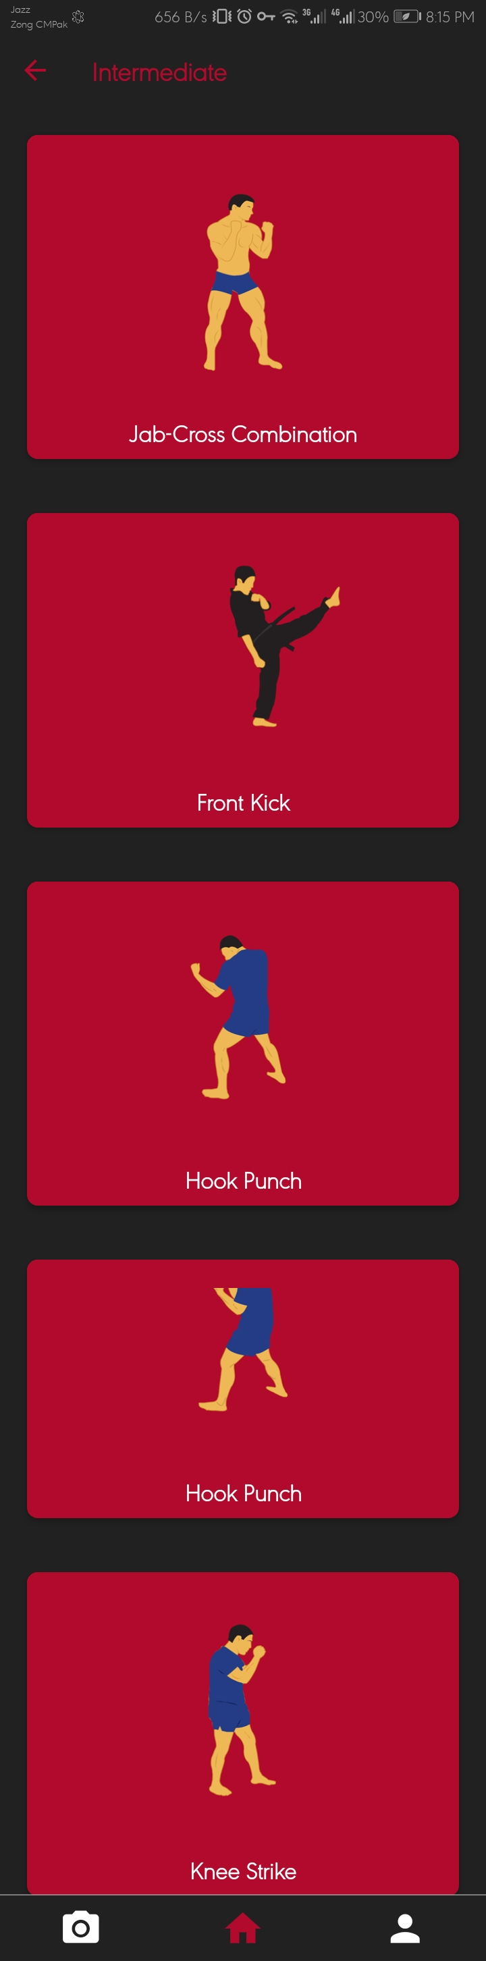

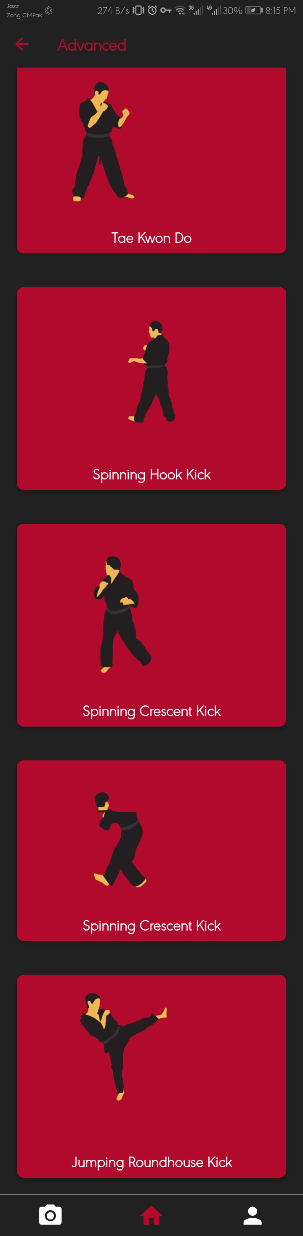
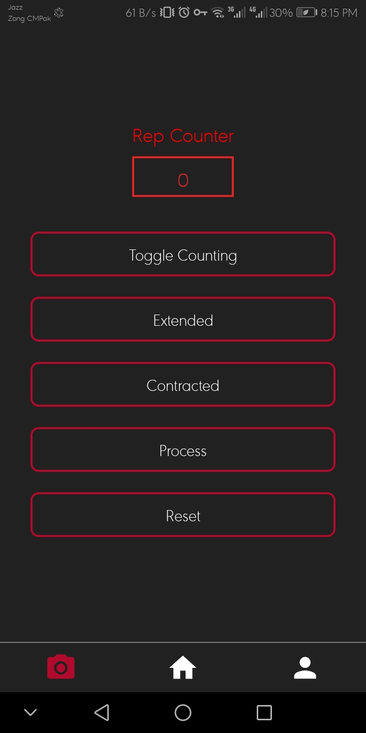

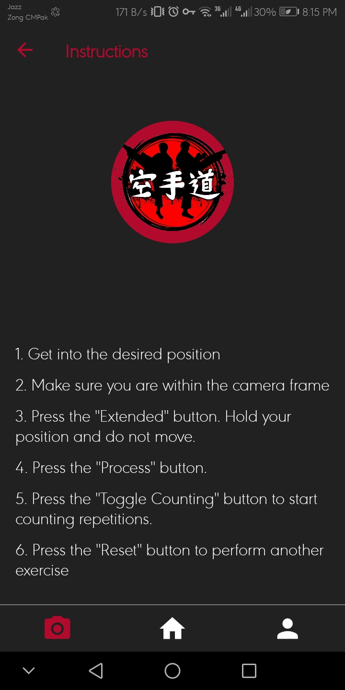

Test Specification and Results

Test Case Specification
Table 6.1: TC-1
Identifier | User login and registration
Related requirements(s) | User login and registration
Short description | Verify user can create an account and log in successfully
Pre-condition(s) | The application is installed on the user's device and the user has a stable internet connection.
Input data | Valid email address, username, and password
Detailed steps | - Open the application.  - Tap on the "Sign up" button.  - Enter a valid email address, username, and password.  - Tap on the "Create account" button.  - Check the confirmation email in the provided email inbox and click on the link to activate the account.  - Open the application.  - Tap on the "Log in" button.  - Enter the registered email and password.  - Tap on the "Log in" button.
Expected result(s) | User should be able to successfully create an account and log in without any errors.
Post-condition(s) | User account is created and logged in successfully.
Table 6.1: TC-2
Identifier | profile
Related requirements(s) | User profile management
Short description | Verify user can update their profile information
Pre-condition(s) | User is logged in to their account.
Input data | Updated user information
Detailed steps | - Open the application.  - Tap on the user profile icon.  - Tap on the "Edit profile" button.  - Update any desired fields (e.g., name, profile picture, training level, etc.).  - Tap on the "Save changes" button.
Expected result(s) | User profile should be updated with the new information.
Post-condition(s) | User profile is updated successfully.

Table 6.1: TC-3
Identifier | Programs
Related requirements(s) | Training program selection
Short description | Verify user can select a training program
Pre-condition(s) | User is logged in to their account.
Input data | User is logged in to their account.
Detailed steps | - Open the application.  - Tap on the "Training programs" button.  - Select a desired training program.  - Tap on the "Select" button.
Expected result(s) | User should be able to select a training program without any errors.
Post-condition(s) | User has selected the desired training program.
Table 6.1: TC-4
Identifier | User login and registration
Related requirements(s) | Workout tracking
Short description | Verify user can track their workouts
Pre-condition(s) | User is logged in to their account and has selected a training program.
Input data | Workout tracking data
Detailed steps | - Open the application.  - Tap on the selected training program.  - Select the desired workout session.  - Tap on the "Start" button to begin the workout.  - Follow the workout instructions and record the data (e.g., reps, sets, weights, etc.).  - Tap on the "Complete" button when finished.
Expected result(s) | User should be able to track their workout data without any errors.
Post-condition(s) | Workout data is recorded and saved to the user's account.
Table 6.1: TC-5
Identifier | tutorials
Related requirements(s) | Animation tutorials
Short description | Verify user can watch Animation tutorials
Pre-condition(s) | User is logged in to their account and has selected a training program.
Input data | Animation tutorial selection
Detailed steps | - Open the application.  - Tap on the selected training program.  - Select the desired Animation tutorial..  - Watch the Animation tutorial in its entirety.
Expected result(s) | User should be able to watch Animation tutorials without any errors.
Table 6.1: TC-6
Identifier | Change program
Related requirements(s) | Training program customization
Short description | Verify user can create a custom training schedule
Pre-condition(s) | User is logged in to their account and has selected a training program.
Input data | User custom training schedule
Detailed steps | - Open the application.  - Navigate to the selected training program.  - Tap on the "Create Custom Schedule" button.  - Select the start date and end date for the custom training schedule.  - Choose the days of the week and time slots for each training session.  - Save the custom training schedule.  - View the custom training schedule in the "My Training Schedule" section.
Expected result(s) | User should be able to create a custom training schedule that fits their individual needs and preferences
Post-condition(s) | User has created a custom training schedule.

Project Completion Status/Conclusion
Table 7.1: Project Completion Status
Module Name | Status  (Complete, Partially Implemented, Not Implemented)
User profile | Completed
Instructor profile | Completed
Badge system | Completed
Training modes | Completed
Animated clips | Completed
Repetition counter using openCV | Implemented
Progress track | Not implemented
Schadule | Not implemented

References
- [1]Free AWS Architecture Diagram Tool (visual-paradigm.com)

- [2] https://krazytech.com/projects

- [3]App Development 101 - Software Requirements Specification | Altamira Developers

Appendix B IV & V Report
(Independent verification & validation)
IV & V Resource

Name Signature

S# | Defect Description | Origin Stage | Status | Fix Time
 |  |  |  | Hours | Minutes
1
2
3
…
Table B.1: List of non-trivial defects

Deployment/Installation Guide
System Requirements:
- Before installing the application, ensure that your device meets the following requirements:
- Operating System: Android 6.0 (Marshmallow) or later, iOS 12 or later.
- Memory: Minimum 2GB RAM.
- Storage: Sufficient free storage space for the application and downloaded content.
- Camera: A device with a front-facing camera is required for the repetition counting feature.

Download and Installation:
Follow the steps below to download and install the Martial Arts Training Mobile
Application:
For Android:
- Open the Google Play Store on your Android device.
- Search for "Martial Arts Training" in the search bar.
- Locate our application in the search results and tap on it.
- Tap the "Install" button to begin the installation process.
- Once the installation is complete, tap "Open" to launch the application.

Application Setup:
- Upon launching the application for the first time, you will be guided through the initial setup process. Follow the on-screen instructions to complete the setup, including granting necessary permissions (e.g., camera access) and creating a user profile.

Training Levels:
- The Martial Arts Training Mobile Application offers three levels of training: basic, intermediate, and advanced. To switch between levels, follow these steps:
- Open the application and log in using your credentials.
- Navigate to the main menu or dashboard.
- Look for an option labeled "Training Levels" or similar.
- Tap on the desired training level to access the corresponding training content.

Animated Training GIFs:
The application provides animated training GIFs to help you better understand the
techniques. To access the GIFs:
- Open the application and select the desired training level.
- Within each training session, you will find instructional GIFs accompanying the exercises.
- Tap on the GIFs to play or pause them as needed.
- Use the on-screen controls to navigate through the GIFs or replay them.

Repetition Counting via Camera:
The application utilizes your device's camera to count the repetitions during exercises. To
use this feature:
- Open the application and select the desired training level.
- Choose an exercise that supports repetition counting.
- Position your device in a stable position, ensuring the exercise is visible within the camera frame.
- Start performing the exercise while keeping it within the camera's view.
- The application will track your movements and count the repetitions automatically.

Troubleshooting:
If you encounter any issues or need assistance with the application, please refer to the
following resources:
- FAQs and troubleshooting section within the application.
- User support forum or community on our website.
- Contact our customer support team via email or phone for further assistance.

Congratulations! You are now ready to deploy and install our Martial Arts Training Mobile
Application. Enjoy your training and make the most

User Manual
Introduction:
Welcome to the user manual for the Martial Arts Training Mobile Application. This manual will provide you with detailed instructions on how to use the application effectively. The application is designed to assist you in your martial arts training journey by offering three levels of training (basic, intermediate, and advanced), animated training gifs for visual guidance, and a camera-based repetition counting feature for exercise tracking.

Getting Started:
2.1 Installation:
- Follow the deployment/installation guide provided to download and install the Martial Arts Training Mobile Application on your device.
- Ensure that you meet the system requirements mentioned in the guide.
2.2 Application Setup:
- Upon launching the application for the first time, you will be guided through the initial setup process.
- Follow the on-screen instructions to grant necessary permissions (e.g., camera access) and create a user profile.

Training Levels:
The Martial Arts Training Mobile Application offers three levels of training: basic, intermediate, and advanced. Each level provides a progression of techniques and difficulty. To access different training levels:
- Log in to the application using your credentials.
- Navigate to the main menu or dashboard.
- Look for an option labeled "Training Levels" or similar.
- Tap on the desired training level to access the corresponding training content.

Training Sessions:
Within each training level, you will find multiple training sessions that focus on specific techniques or skills. To start a training session:
- Select the desired training level.
- Choose a training session from the available list.
- Read the description and instructions for the session.
- Tap the "Start" button to begin the training session.

Animated Training GIFs:
The application includes animated training GIFs to provide visual guidance for the techniques. To use the GIFs effectively:
- Within a training session, you will find instructional GIFs accompanying the exercises.
- Tap on the GIFs to play or pause them as needed.
- Use the on-screen controls to navigate through the GIFs or replay them.

Repetition Counting via Camera:
The application utilizes your device's camera to count the repetitions during exercises. Follow these steps to use this feature:
- Choose an exercise within a training session that supports repetition counting.
- Position your device in a stable position, ensuring the exercise is visible within the camera frame.
- Start performing the exercise while keeping it within the camera's view.
- The application will track your movements and count the repetitions automatically.

Troubleshooting and Support:
If you encounter any issues or need assistance with the application, follow these steps:
- Check the FAQs and troubleshooting section within the application for common issues and solutions.
- Visit our user support forum or community on our website for further assistance.
- Contact our customer support team via email or phone for personalized support.

Congratulations! You are now familiar with the features and usage of the Martial Arts Training Mobile Application. Enjoy your training and make the most out of the application's capabilities.

Troubleshooting FAQs:

Q: The application is not installing on my device. What should I do?
A: Please ensure that your device meets the minimum system requirements mentioned in the deployment/installation guide. Additionally, check your internet connection and try restarting your device before attempting the installation again.

Q: I'm experiencing crashes or freezing issues within the application. How can I resolve this?
A: Crashes or freezing can occur due to various factors. Try the following steps:
Close the application and restart it.

Clear the application cache from your device settings.
Ensure that you have the latest version of the application installed.
If the issue persists, uninstall and reinstall the application.

Q: The animated training GIFs are not loading or playing correctly. What should I do? A: Slow internet connectivity or insufficient device memory can affect the loading and playback of GIFs. Try the following troubleshooting steps:
Check your internet connection and ensure it is stable.
Free up some space on your device by deleting unnecessary files.
If the issue persists, try accessing the GIFs on a different network or device.

Q: The camera-based repetition counting feature is not accurately tracking my movements. How can I improve its performance?
A: The accuracy of the camera-based repetition counting feature can vary based on various factors. Here are some tips to improve its performance:
Ensure that the exercise is performed in a well-lit environment.
Make sure your device's camera lens is clean and free from obstructions.
Position your device at a suitable distance and angle to capture your movements effectively.
Follow the on-screen instructions for each exercise and perform the movements as accurately as possible.

Q: I forgot my login credentials. How can I reset my password?
A: If you have forgotten your login credentials, look for a "Forgot Password" or similar option on the login screen. Follow the instructions provided to reset your password. Alternatively, you can reach out to the application's customer support for assistance with account recovery.

Q: I completed a training session, but my progress is not updating. What could be the issue?
A: Ensure that you have a stable internet connection during and after completing a training session. The progress tracking may require an active internet connection to sync your data. If the issue persists, try closing and reopening the application or logging out and logging back in to force a sync.

Q: I encountered a bug or technical issue in the application. How can I report it?
A: We appreciate your feedback in identifying and resolving bugs or technical issues. Look for an option within the application labeled "Report a Bug" or "Contact Support." Provide a detailed description of the issue you encountered, along with any relevant screenshots or error messages, if available.

Q: The application is not displaying properly on my device's screen. What should I do?
A: If you are experiencing display issues, try the following steps:
Ensure that your device's screen resolution and orientation settings are compatible with the application.
Close and reopen the application to see if the issue resolves.
If the problem persists, uninstall and reinstall the application.

Q: I'm not receiving any notifications from the application. How can I enable them?
A: Check your device's notification settings to ensure that notifications from the application are not blocked. Additionally, within the application's settings, verify that you have enabled notifications and selected the desired notification preferences.

Q: I have a question or issue that is not covered in the FAQs. How can I get further assistance?
A: If you have a question or issue that is not addressed in the FAQs, you can reach out to the application's customer support team. Look for contact information within the application or on the developer's website. Provide them with a detailed description of your question or issue, and they will be able to assist you further.
If you encounter any difficulties or have additional questions, feel free to reach out to our customer support team for prompt assistance.

